**Assignment no-1**

**1)**Write a program to check given number is armstrong or not?

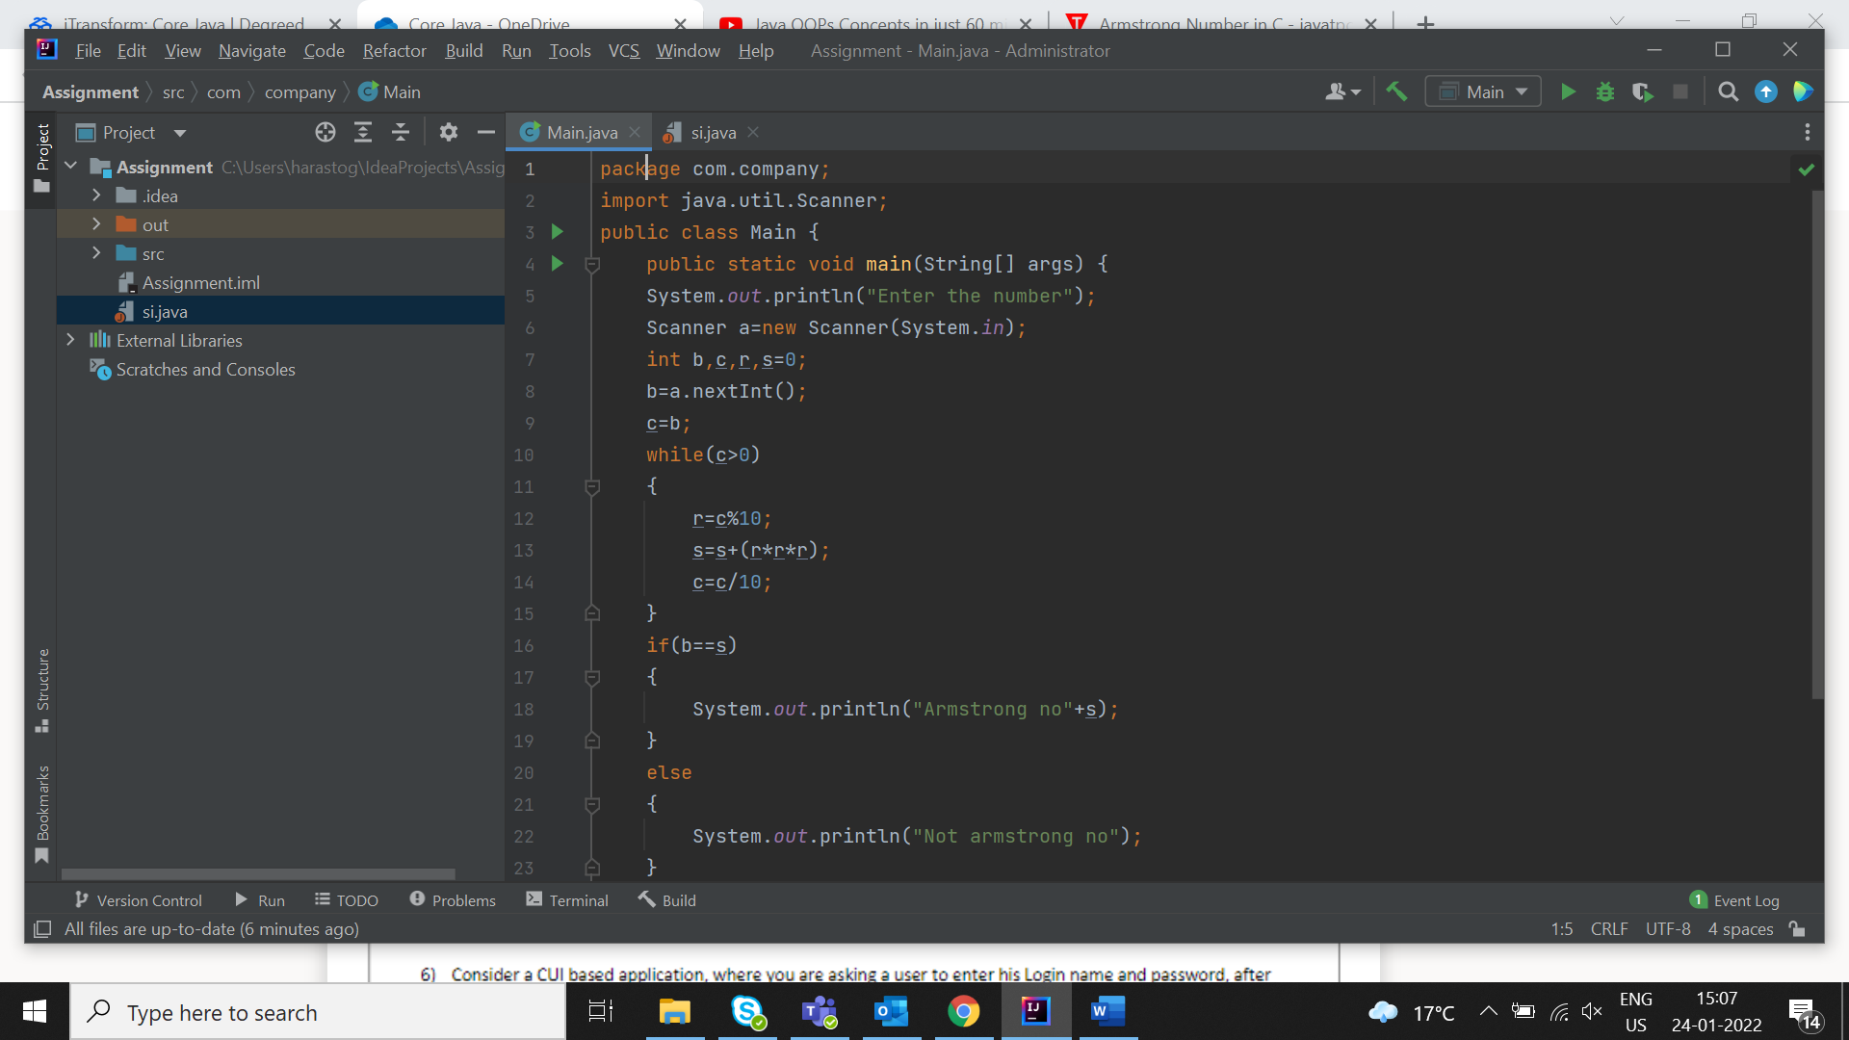

2)Write a program to calculate the SI and CI?

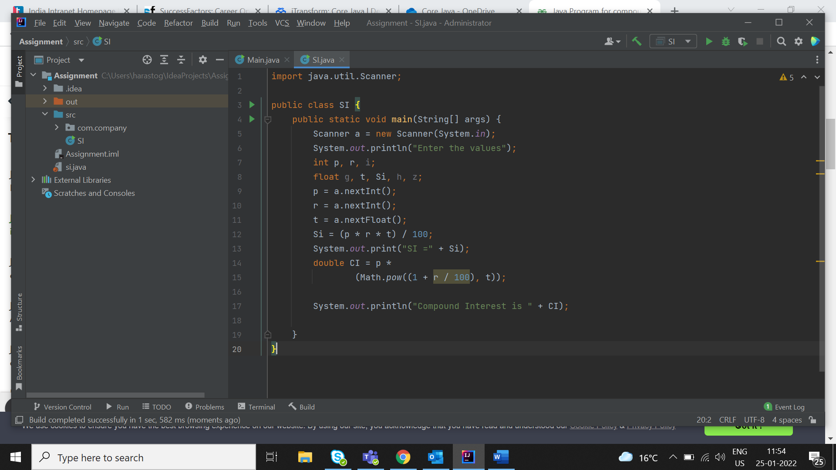

3)Write a program to find the results on the basis of there conditions?

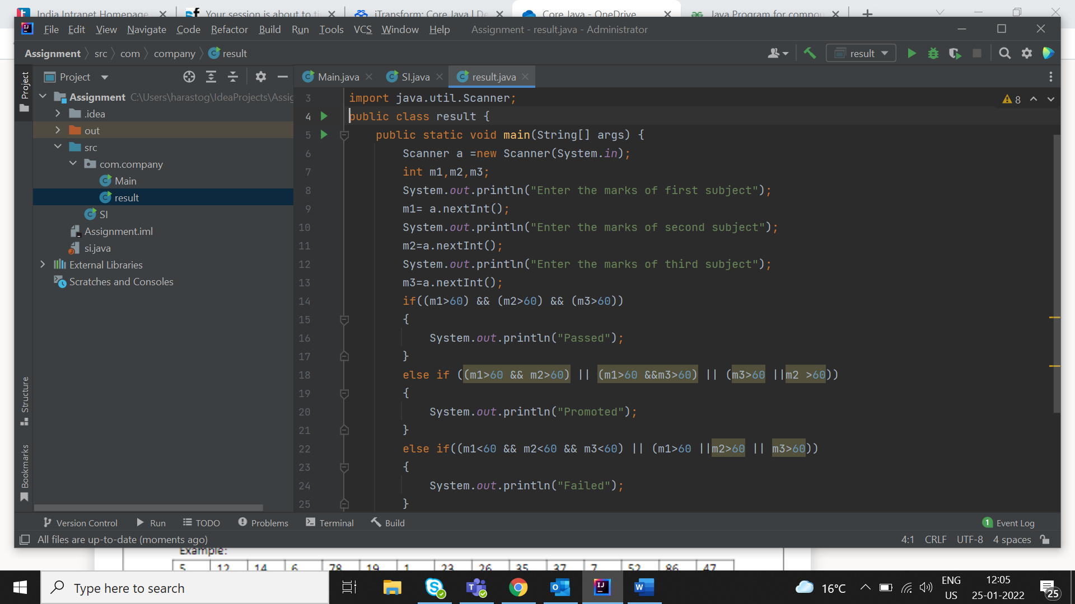

4)Calculate the income tax on basis of there salary structure?

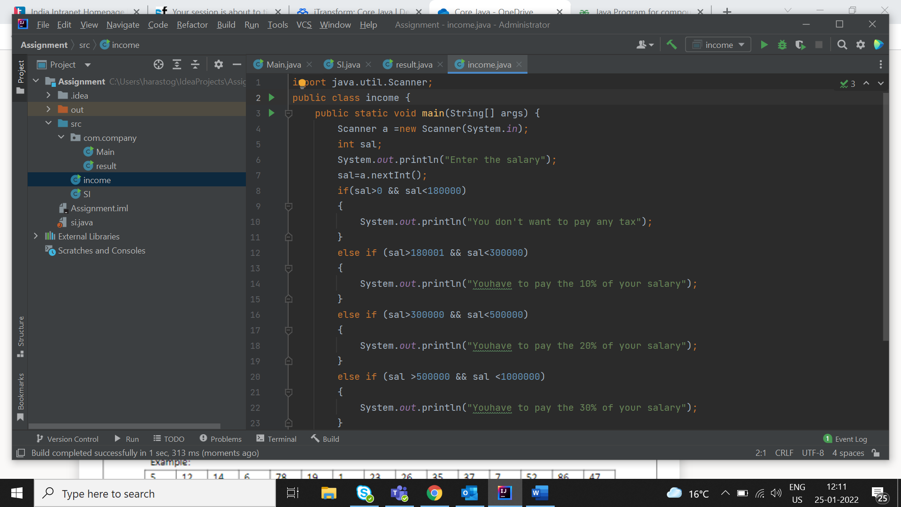

5)Write a program to take input from user in an array and searched on it?

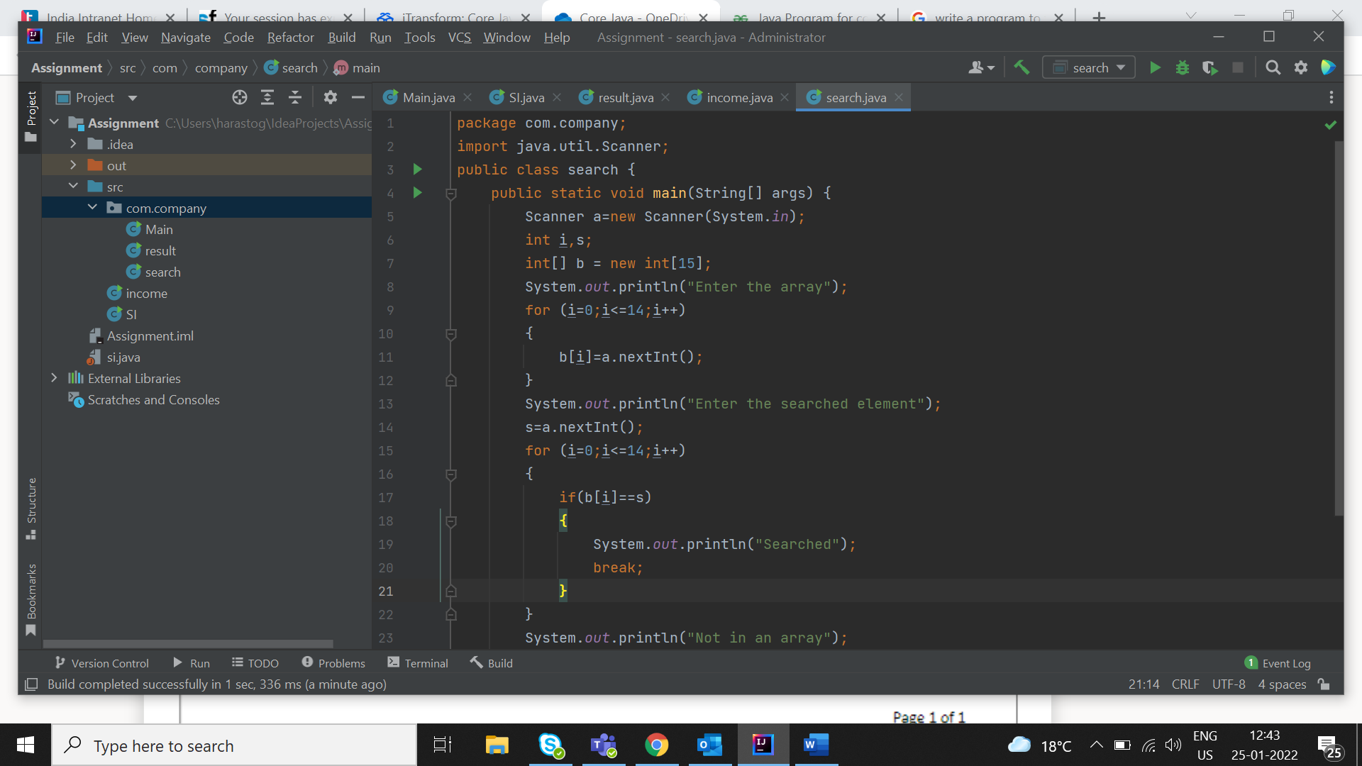

6)Write a program for a bubble sort?

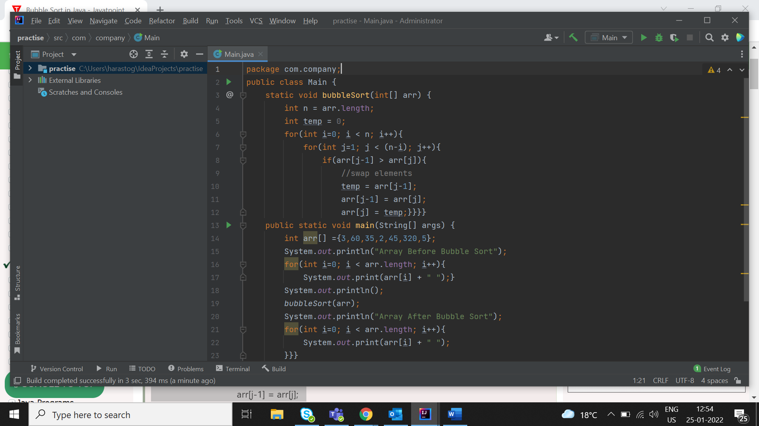

7)Write a program to take a input from user and find its total marks and average?

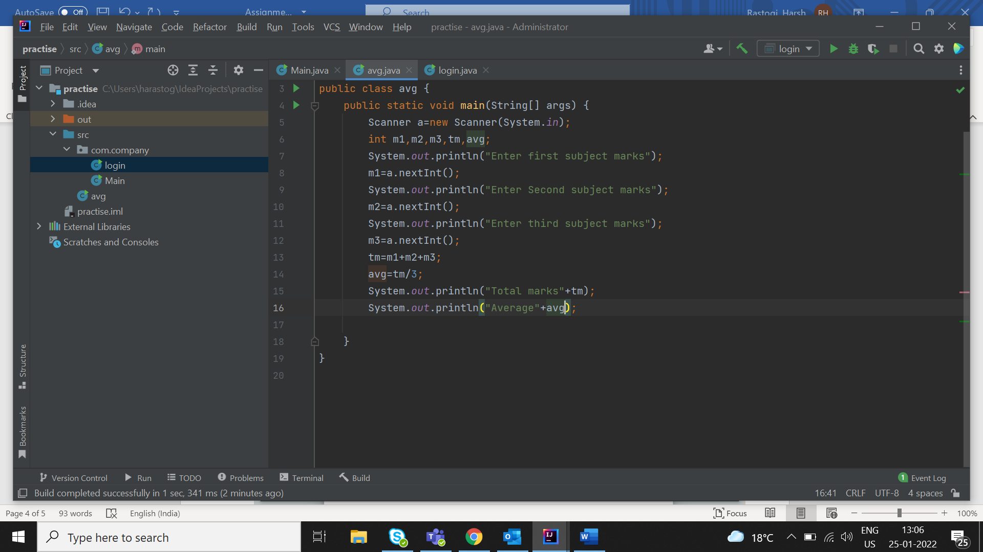

8)Write a program to check user is valid or not?

